The 1st International Congress On Logistics And SCM Systems (ICLS-2004)

22nd-24th-, Nov., 2004.

Call for Papers:-Cutting Edge Technology of Logistics and SCM-The 1st Announcement

INTRODUCTION
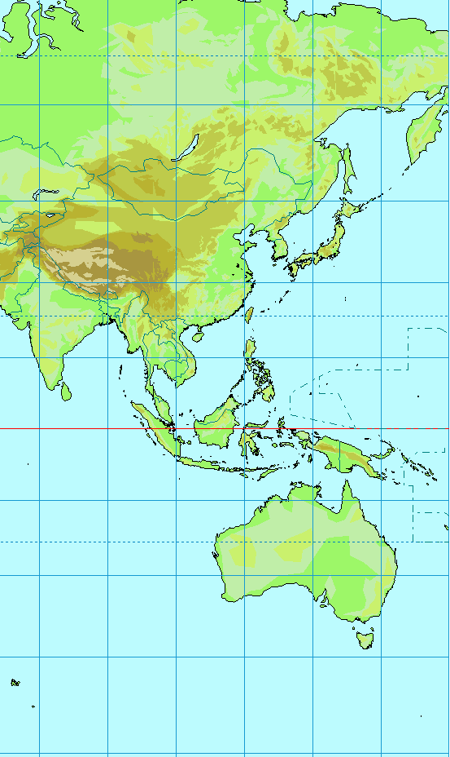
The International Congress on Logistics and SCM Systems is organized by The Asia Federation of Logistics & SCM Systems. The 1st general event of this new federation is hosted by The Japan Society of Lojistics Systems under cooperation of Kanagawa University in Yokohama,Japan from Aug.22nd to 24th
.in 2007.
The Congress aims to provide a forum for delegates from academia and industry to exchange information and ideas. Hence, papers are invited from researchers and also from practitioners in the related areas who wish to report the development and application of an innovative concept, strategy, systems, organization, process or technique.

DOMESTIC ORGANIZING COMMITTEE
Co-Chairman:
FUJIMOTO, Takahiro (The University of Tokyo)
KATAYAMA, Hiroshi (Waseda University)
KITAOKA, Masatoshi

Co-Vice Chairman:
FUKANO, Hiroyuki, Aichi Gakusen University
HIRAKI, Shusaku, Hiroshima Shudo University
KATAYAMA, Toru, Kyoto University
KATO, Sadao, Tokai University
KITAOKA, Masatoshi, Kanagawa University
KOKURYO, Jiro, Keio University
KONDO, Mitsuo, Tokushima University
KUMAGAYA, Sadatoshi, Osaka University
MORI, Kenichi, Kansai University
NAKANO, Masaru, Toyota Central Research Laboratory
OHNO, Katsuhisa, Nagoya Institute of Technology
OHTA, Masaharu, Osaka City University
SAKAMOTO, Isao, Ajinomoto Logistics
SATO, Keiichi, Hokkaido University
SUGAWARA, Mitsumasa, Iwate Prefectural University
SUGIHARA, Toshio, Nagasaki University
SUMIYOSHI, Kazushi, Osaka Institute of Technology
SUZUKI, Takeo, Fuji Logistics
TAKAKUWA, Soemon, Nagoya University
TAKAHASHI, Hitoshi, Bunkyo University
TAKEISHI, Akira, Hitotsubashi University
TAMURA, Takayoshi, Aichi Institute of Technology
YASUDA, Kazuhiko, Tohoku University

Organized by
THE ASIA PACIFIC FEDERATION OF LOGISTICS AND SCM SYSTEMS

Chairman: KARASAWA, Yutaka, Dr. Engg.,
Seijoh University, Japan
Vice Chairman: FUJIMOTO, Takahiro, DBA, The
University of Tokyo, Japan
KATAYAMA, Hiroshi, Dr. Engg.,
Waseda University, Japan
Lee, Young Hae, Ph.D, Hanyang University,
Korea
Feng,Chen-Min,Ph.D,National Chiao Tung
University,Taiwan

Co-organized by
- The Japan Society of Logistics Systems
- The Korean Society of SCM
- The Taiwan Society of Logistics Systems
- The International Federation of Logistics & SCM Systems
- The Asia Pacific Federation of Logistics and SCM
Systems

ICLS
THE ASIA PACIFIC FEDERATION OF
LOGISTICS & SCM SYSTEMS

INTERNATIONAL ADVISORY COMMITTEE

CHANDRA, Lalwani, Dr. Eng., Cardiff University, U.K.
FENG, Chen-Min, Ph.D., National Chiao Tung University, Taiwan
FUJIMOTO, Takahiro, DBA, The University, of Tokyo, Japan
KARASAWA, Yutaka, Dr. Eng., Kanagawa University, Japan
KATAYAMA, Hiroshi, Dr. Eng., Waseda University, Japan
LEE, Young Hae, Ph.D., Hanyang University, Korea
LIN, Cheng-Chang, Ph.D., National Cheng-Kung University, Taiwan
LIN, Lie-Chien, Ph.D., National Kaohsiung University of Science and Technology
SADLER, lan, Ph.D., Victoria University, Australia
SOHAL, Amric, Dr. Eng. Monash University
TSAI, Ming-Chih, Ph.D., National ChungHsing University, Taiwan
RAHMAN, Shams, Dr. Eng., The University of Sydney, Australia
WU, Qingyi, Beijing University of Science and Technology
Hoki Nam, Dr. Eng., Incheon University, Korea
Hyun-Soo Han, Dr. Information&Communication , Hanyang University

THE INTERNATIONAL FEDERATION OF
LOGISTICS & SCM SYSTEMS
INTERNATIONAL ADVISORY COMMITTEE

FENG, Chen-Min, Ph.D., National Chiao Tung University, Taiwan
FUJIMOTO, Takahiro, Professor, The University of Tokyo, Japan
HINES, Peter, Dr. Engg., Cardiff University, U.K.
KARASAWA, Yutaka, Dr. Engg., Kanagawa University, Japan
KATAYAMA, Hiroshi, Dr. Engg., Waseda University, Japam
LEE, Young Hae, Ph.D., Hanyang University, Korea
LIN, Cheng-Chang, Ph.D., National Cheng-Kung University, Taiwan
LIN, Lie-Chien, Ph.D., National Kaohsiung University of Science and Technology
MUFFATTO, Moreno, Dr. Engg., University of Padua, Italy
PAWAR, Kulwant, Dr. Engg., University of Nottingham, U.K.
ROBINSON, Ross, Dr. Engg., Victoria University, Australia
SOHAL, Amric, Dr. Engg., Monash University
TSAI, Ming-Chih, Ph.D., National ChungHsing University, Taiwan

( As of Jan 1 2004 )

CONGRESS TOPICS
In keeping with the aim of the Conference, its theme will be “Asia Pacific Cutting Edge Logistics and SCM”. Papers written in English will be considered on all aspects of Logistics and SCM, including the following:

- International Supply Chain Networks
- Global Logistics
- Procurement & Delivery Strategies
- Design and Management of the Customer-Supplier Relationship
- Organizational and Managerial Aspects in Logistics
- Outsourcing
- Distribution and Third Party Logistics
- Logistics Planning and Control Models
- Supply Chain Performance Assessment
- Logistics Engineering
- JIT or Lean Logistics in the Service Sector
- Decision Support Systems and Communication Technologies
- e-business, e-logistics and Supply Chain Developments
- Supplier Involvement in Product Development
- Life-Cycle Costing and Assessment
- Reverse Manufacturing and Logistics
- Environmental Logistics
- Reliability & Maintainability
- Plant and Warehouse Location Problems
- Vehicle Routing & Inter-plant Transportation
- Warehousing & Automation
- In-plant Logistics
- Inventory Management

SUBMISSION OF ABSTRACTS
Authors are requested to submit abstracts of approximately 250 words by post or e-mail, along with a completed preliminary registration form. Abstracts will be reviewed and authors notified of the outcome. Authors of accepted abstracts will then be asked to produce a camera ready version of the full paper. Submitted papers will be peer reviewed.

IMPORTANT DATES
Latest Date for Abstracts:  Notification of Acceptance:  Latest Date for Papers:  Latest Date for Registration: | 1st, Feb., 2004  1st, June, 2004  1st, Sept., 2004  1st, Oct., 2004

REGISTRATION FEES (Transfer Charge is excluded)
Presenting Author:  Co-author:  Delegate:  Research Student:  One Day Attendance: | JPN\ 40,000  JPN\ 40,000  JPN\ 50,000  JPN\ 20,000  JPN\ 20,000

The full registration fees will cover all sessions of the Conference, a hard copy and a CD-ROM of the Proceedings, Refreshments, Lunches, the Conference Dinner (22nd) and an Plant Tour (24th). A Welcoming Reception will be held for delegates arriving on Monday 21st November. Registration fees will not be refunded after 1st, Oct., 2004. Cancellations before 1st, Oct., 2004 may be subject to an administration fee of JPN\ 5,000.

PROCEEDINGS
All papers submitted by 1st, Sept., 2004 will be reviewed for publication in the Proceedings, provided they are accompanied by the appropriate Registration fee for at least one author. If a paper is deemed unacceptable for any reason then the full Registration fee will be refunded. Following the Conference, authors of selected contributions will be requested to submit developed articles to be considered for publication in the following journals:
International Journal of Logistics: Research and Applications
APFLS Journal

ACCOMPANYING PERSONS
Spouses and partners are welcome to attend the Reception, the Keynote Address and the Plant Tour at no charge. There is a JPN\ 10,000 charge for the Conference Dinner.

ACCOMMODATION
Full information on a range of budget accommodation and nearby hotels and a map of the local area will be sent to those who return the preliminary form. Delegates will be responsible for booking their own accommodation.

CONGRESS ADMINISTRATION
C/O Prof. KATAYAMA, Hiroshi, Dr. Engg.
Department of Industrial and Management Systems Engineering, School of Science and Engineering,
Waseda University
Ohkubo 3-4-1, Shinjuku Ward, Tokyo, Japan (post code 169-8555)

Phone & Fax: +81(0)3-5286-3297
e-mail: kata@kata.mgmt.waseda.ac.jp

JSLS Office
C/O Prof. KARASAWA, Yutaka, Dr. Engg.
Department of Industrial Engineering and Management, Faculty of Engineering, Kanagawa University
Rokkaku Bashi 3-27-1, Kanagawa Ward, Yokohama, Japan (post code 221-8686)
Phone: +81(0)45-481-5661 ext.3730-3732
Fax: +81(0)45-413-6565
e-mail: jsls@kar.ie.kanagawa-u.ac.jp

PRELIMINARY REGISTRATION FORM

□I am interested in attending ICLS-2004
□I enclose an abstract for ICLS-2004

Surname:

First Name:

Title:

Affiliation:

Address:

Tel:

Fax:

e-mail:

Please return by e-mail or Fax. to

Prof. KATAYAMA, Hiroshi, Dr. Engg.
Department of Industrial and Management Systems Engineering, School of Science and Engineering,
Waseda University
Ohkubo 3-4-1, Shinjuku Ward, Tokyo, Japan (post code 169-8555)
Phone & Fax: +81(0)3-5286-3297
e-mail: kata@kata.mgmt.waseda.ac.jp

