The 3rd International Congress On Logistics and SCM Systems (ICLS-2007)

28-30,Aug.,07

Call for Papers:-World Wide KAIZEN in SCM and Logistics
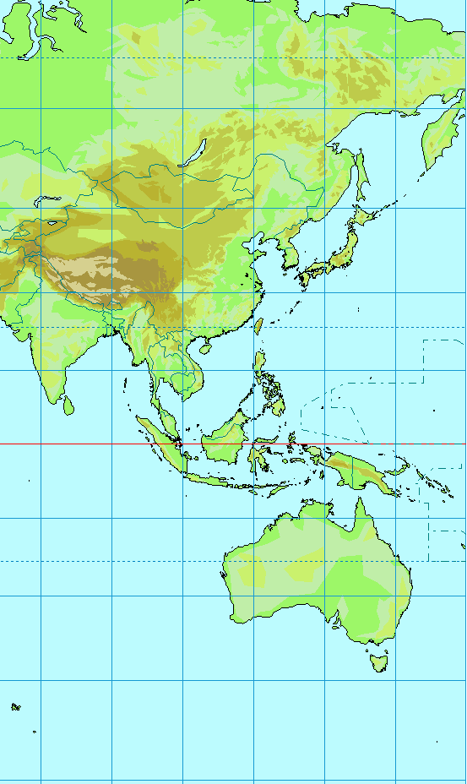

INTRODUCTION
The International Congress on Logistics and SCM Systems is organized by The International Federation of Logistics & SCM Systems. The 1st general event of this new federation was hosted by Waseda University in Tokyo, Japan from 22nd to 24th November 2004, followed by The 2nd conference hosted by The National First University of Science and Technology in Kaoshung,Taiwan.The Congress aims to provide a forum for delegates from academia and industry to exchange information and ideas. Hence, papers are invited from researchers and also from practitioners in the related areas who wish to report the development and application of an innovative concept, strategy, systems, organization, process or technique.

DOMESTIC ORGANIZING COMMITTEE
Chairperson
Masatoshi Kitaoka Kanagawa University
Co-Vice Chairperson
CHIBA,Hiromasa, Sapporo University
FUKANO Hiroyuki, Aichi Gakusen University
GEN Mitsuo, Waseda University
HIRAKI, Shuzohu, Hiroshima Shudo University
KATAYAMA, Toru, Doshisya University
KUMAGAYA, Sadatoshi, Osaka University
KUMAMOTO, Hiroshi, Kyoto University
NAKANO, Masami, Toyota Central Laboratory
Noma, Tsukasa, Kyuusyuu Institute of Technology
OHNO, Katsuhisa, Aichi Institute of Technology
SATO, Keiich, Hokkaido University
SHIODA ,
SUGAWARA, Mitsumas, ,Iwate Prefectural University
SUMIYOSHI, Kazush,I, Osaka Institute of Technology
SUZUKI, Takeo, Fuji Logitech
Takakuwa Souemonn ,Nagoya University
TAKEISHI,Akira, Hitotubashi University
TAMURA, Takayoshi, Aichi Institute of Technology
YASUDA Kazuhiko, Tohoku University
WAKABAYAShI, Keizo, Nippon University
Organized by
THE INTERNATIONAL FEDERATION OF LOGISTICS AND SCM SYSTEMS

Chairman: KARASAWA, Yutaka, Dr. Engg.,
Kanagawa University, Japan
Vice Chairman: FUJIMOTO, Takahiro, DBA, The
University of Tokyo, Japan
KATAYAMA, Hiroshi, Dr. Engg.,
Waseda University, Japan
Lee, Young Hae, Ph.D, Hanyang University,
Korea
Lin, Cheng-Chang, Ph.D., National Cheng-Kung University, Taiwan
Executive Director: Feng, Chen-Min, Ph.D.& Professor, National Chiao Tung
University, Taiwan
Han, Hyun-Soo, Assistant Professor, Hanyang University, Korea
Nam, Hoki, Professor, Incheon University, Korea
Tsai, Ming-Chih, Ph.D. & Associate Professor, National Cheng-Kung University, Taiwan

Co-Organized by
- The Japan Society of Logistics Systems
- The Korean Society of SCM
- The Taiwan Society of Logistics Systems
- The Asia Pacificl Federation of Logistics & SCM Systems
Hosted by
Kanagawa University
THE INTERNATIONL FEDERATION OF
ICLS
LOGISTICS and SCM SYSTEMS

INTERNATIONAL ADVISORY COMMITTEE

CHANDRA, Lalwani, Dr. Engg., Cardiff University, U.K.
FENG, Chen-Min, Ph.D., National Chiao Tung University, Taiwan
FUJIMOTO, Takahiro, DBA, The University, of Tokyo, Japan
KARASAWA, Yutaka, Dr. Engg., Kanagawa University, Japan
KATAYAMA, Hiroshi, Dr. Engg., Waseda University, Japan
LEE, Young Hae, Ph.D., Hanyang University, Korea
LIN, Cheng-Chang, Ph.D., National Cheng-Kung University, Taiwan
LIN, Lie-Chien, Ph.D., National Kaohsiung University of Science and Technology
SADLER, lan, Ph.D., Victoria University, Australia
SOHAL, Amrik, Dr. Engg. Monash University
TSAI, Ming-Chih, Ph.D., National Cheng-Kung University, Taiwan
RAHMAN, Shams, Dr. Engg., The University of Sydney, Australia
WU, Qingyi, Beijing University of Science and Technology

THE INTERNATIONAL FEDERATION OF
LOGISTICS and SCM SYSTEMS
INTERNATIONAL ADVISORY COMMITTEE

FENG, Chen-Min, Ph.D., National Chiao Tung University, Taiwan
FUJIMOTO, Takahiro, DBA, The University of Tokyo, Japan
HINES, Peter, Dr. Engg., Cardiff University, U.K.
KARASAWA, Yutaka, Dr. Engg., Kanagawa University, Japan
KATAYAMA, Hiroshi, Dr. Engg., Waseda University, Japam
LEE, Young Hae, Ph.D., Hanyang University, Korea
LIN, Cheng-Chang, Ph.D., National Cheng-Kung University, Taiwan
LIN, Lie-Chien, Ph.D., National Kaohsiung University of Science and Technology
MUFFATTO, Moreno, Dr. Engg., University of Padua, Italy
PAWAR, Kulwant, Dr. Engg., University of Nottingham, U.K.
ROBINSON, Ross, Dr. Engg., Victoria University, Australia
SOHAL, Amrik, Dr. Engg., Monash University
TSAI, Ming-Chih, Ph.D., National Cheng-Kung University, Taiwan

NOTE：
I.F.L.S. Journal of Logistics and SCM System is expected to be published after ICLS-2007, based on selected papers of proceedings and contributed papers.

( As of July 30, 2007 )

CONGRESS TOPICS
In keeping with the aim of the Conference, its theme will be “Asia Pacific Cutting Edge Logistics and SCM”. Papers written in English will be considered on all aspects of Logistics and SCM, including the following:

- International Supply Chain Networks
- Global Logistics
- Procurement & Delivery Strategies
- Design and Management of the Customer-Supplier Relationship
- Organizational and Managerial Aspects in Logistics
- Outsourcing
- Distribution and Third Party Logistics
- Logistics Planning and Control Models
- Supply Chain Performance Assessment
- Logistics Engineering
- JIT or Lean Logistics in the Service Sector
- Decision Support Systems and Communication Technologies
- e-business, e-logistics and Supply Chain Developments
- Supplier Involvement in Product Development
- Life-Cycle Costing and Assessment
- Reverse Manufacturing and Logistics
- Environmental Logistics
- Reliability & Maintainability
- Plant and Warehouse Location Problems
- Vehicle Routing & Inter-plant Transportation
- Warehousing & Automation
- In-plant Logistics
- Inventory Management

SUBMISSION OF ABSTRACTS
Authors are requested to submit abstracts of approximately 250 words by post or e-mail, along with a completed preliminary registration form. Abstracts will be reviewed and authors notified of the outcome. Authors of accepted abstracts will then be asked to produce a camera ready version of the full paper. Submitted papers will be peer reviewed.

<IMPORTANT DATES;>

REGISTRATION FEES (Transfer Charge is excluded)
 | Early RAte | Normal Rate
- Presenting Author:  - Co-author:  - Delegate:  - Research Student:  - One Day Attendance: | JPN\ 40,000  JPN\ 40,000  JPN\ 50,000  JPN\ 20,000  JPN\ 20,000 | JPN\ 45,000  JPN\ 45,000  JPN\ 55,000  JPN\ 25,000  JPN\ 25,000
(Payment must be made in \en)
if paying by credit card, please indicate：□ VISA □ Master □
Exp. Date

Card No. Signature

The full registration fees will cover all sessions of the Conference, a hard copy and a CD-ROM of the Proceedings, Refreshments, Lunches, the Conference Dinner (xx^{nd}) and an Plant Tour (xx^{th}). A Welcoming Reception will be held for delegates arriving on WWW DDD August. Registration fees will not be refunded after 1st, July., 2007. Cancellations before 1st, July., 2007 may be subject to an administration fee of JPN\ 5,000.

PROCEEDINGS
All papers submitted by 28, Feb., 2007 will be reviewed for publication in the Proceedings, provided they are accompanied by the appropriate Registration fee for at least one author. If a paper is deemed unacceptable for any reason then the full Registration fee will be refunded. Following the Conference, authors of selected contributions will be requested to submit developed articles to be considered for publication in the following journals:
International Journal of Logistics: Research and Applications
IFLS Journal

ACCOMPANYING PERSONS
Spouses and partners are welcome to attend the Reception, the Keynote Address and the Plant Tour at no charge. There is a JPN\ 10,000 charge for the Conference Dinner.

ACCOMMODATION
Full information on a range of budget accommodation and nearby hotels and a map of the local area will be sent to those who return the preliminary form. Delegates will be responsible for booking their own accommodation.

CONGRESS ADMINISTRATION
C/O Prof. KITAOKA,Masatoshi, Dr. Engg.
Department of Industrial and Management Systems Engineering, School of Engineering,.Kanagawa University
Rokkakubashi 3-27-1, Kanagawa-ku, Yokohama 221-8686,
Kanagawa, Japan
Phone: +81(0)45-481-5661 / FAX: +81(0)45-413-6565
e-mail: kitaoka@kit.ie.kanagawa-u.ac.jp

JSLS Office
Address:9-23 Nishi-Gotanda 3-chome,Sinagawa-ku,Tokyo
141-0031,Japan,Exabrain Inc.
Tel: +81-(0)3-5740-8872
Fax: +81-(0)3-5740-8873
e-mail: info@jsls.jp
HP: http://www.jsls.jp

PRELIMINARY REGISTRATION FORM

□I am interested in attending ICLS-2007
□I enclose an abstract for ICLS-2007

Surname:

First Name:

Title:

Affiliation:

Address:

Tel:

Fax:

e-mail:

Please return by e-mail or Fax. to

Prof. KITAOKA,Masatoshi, Dr. Engg.
Department of Industrial and Management Systems Engineering, School of Engineering,.Kanagawa University
Rokkakubashi 3-27-1, Kanagawa-ku, Yokohama 221-8686,
Kanagawa, Japan
Phone: +81(0)45-481-5661 / FAX: +81(0)45-413-6565
e-mail: e-mail: kitaoka@kit.ie.kanagawa-u.ac.jp

